**OCTOBER-2017**

**Q-1[ONE MARK]:**

1]what is SEO?

a. SEO stands for Search Engine Optimization, which is the practice of increasing the quantity and quality of traffic to your website through organic search engine results.

SEO is an acronym that stands for search engine optimization, which is the process of optimizing your website to get organic, or un-paid, traffic from the search engine results page. ... Search engines want to provide the best service for their users.

2]what is informational queries?

a. informational search queries as “Queries that cover a broad topic (e.g., colorado or trucks) for which there may be thousands of relevant results.”

in these instances, the user is looking for certain information– for example, “how to make coffee”.

3]what is on page optimization?

a. On-page SEO (also known as “on-site SEO”) is the practice of optimizing web page content for search engines and users.

4]what is search query box?

a. A search box is a graphical element present in many desktop applications and websites. It acts as the field for a query input or search term from the user to search and retrieve related information from the database.

5]what is spider?

a.A spider is a program that visits Web sites and reads their pages and other information in order to create entries for a [search engine](https://whatis.techtarget.com/definition/search-engine) index.

Spider, sometimes known as "crawler” or "robot", is a software program which is used by search engine to stay up to date with new coming stuff in the internet.

6]what is keyword research?

a. Keyword research is an SEO practice of finding, analyzing and using the phrases people use to search for information on the internet.

7]what is sitemaps?

A. A sitemap is a blueprint of your website that help search engines find, crawl and index all of your website's content. Sitemaps also tell search engines which pages on your site are most important. ... It's usually in the form of an XML Sitemap that links to different pages on your website.

8]what is duplicate content?

a. Duplicate content is content that's similar or exact copies of content on other websites or on different pages on the same website.

9]what is vertical search?

a. A vertical search refers to search on a specific topic area or a specific segment of an overall search. An example of a vertical search is Google Image Search. ... Typical vertical search queries include shopping, travel, cars, medical information, and books.

10]what is action tracking?

a. Action Tracking is a method of logging progress on internet that is a cookie-based method to track actions and page visits.

11]which search engine maximum is used in india?

a.google

12]XML sitemap will be generally uploaded in…

a.root directory

13]Universal search also known as..

a. “Universal Search” (also called “Blended Search” or “Enhanced Search”)

14]when user view the google search result his eye track create…

A. When viewing a standard Google results page, users tended to create an “F-shaped” pattern with their eye movements.

15]give two name search engine

a. google,bing ,yahoo

16]PPC stand for - pay per click.

17]ROI stand for- Return on Investment

18]KEI stand for- keyword effectiveness index)

19]SERP stand for- Search Engine Results Page

20]QDF stand for- “Query Deserves Freshness”

**Q-2[A]TWO MARK:**

1]DEFIN TERM:crawling,indexing

a. Crawling means that Googlebot looks at all the content/code on the page and analyzes it.

Indexing means that the page is eligible to show up in Google's search results. They aren't mutually inclusive.

2]difference between 301 and 302 directs.

a. A 301 redirect means that the page has permanently moved to a new location. A 302 redirect means that the move is only temporary. Search engines need to figure out whether to keep the old page, or replace it with the one found at the new location.

3]what is meta search?

a. A meta search engine is a search tool that sends queries to several other search engines and compiles the results into a list.

A metasearch engine (or search aggregator) is an online Information retrieval tool that uses the data of a web search engine to produce its own results.[1][2] Metasearch engines take input from a user and immediately query search engines for results. Sufficient data is gathered, ranked, and presented to the users.

4]what is keyword cannibalization?

a. Keyword cannibalization means that you have various blog posts or articles on your site that can rank for the same search query in Google. Either because the topic they cover is too similar or because you optimized them for the same keyphrase.

In lay terms “keyword cannibalism” is a situation where multiple pages are targeting the same keyword. ... When multiple pages target a keyword, it creates confusion for the search engines. You do not want to compete between your own pages when your real competitors are waiting for your rankings to fall.

5]what is link neighbourhood?

a. An SEO neighborhood or link neighborhood is kind of like a community in a suburb with houses and streets connecting them. The houses are websites and the streets are the links that work their way to connect them to each other. ... Think about your website and the sites linking into you.

6]what is click tracking?

a. Click tracking is a technique used to determine and record what computer users are clicking with their mouse while browsing the Web. The clicking action is then sent and logged by the client, Web browser or server while the computer user continues to explore and click around the ad application or Web page.

**Q-2[B]THREE MARK:**

1]explain different types of queries

a. Navigational Search Queries

A navigational query is a search query entered with the intent of finding a particular website or webpage. For example, a user might enter "youtube" into Google's search bar to find the YouTube site rather than entering the URL into a browser's navigation bar or using a bookmark. In fact, “facebook” and “youtube” are the top two searches on Google, and these are both navigational queries.

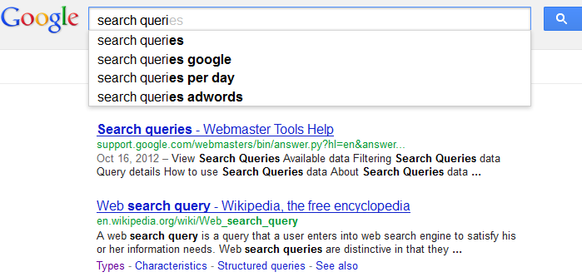

Informational Search Queries

Wikipedia defines informational search queries as “Queries that cover a broad topic (e.g., colorado or trucks) for which there may be thousands of relevant results.” When someone enters an informational search query into Google or another search engine, they’re looking for information – hence the name. They are probably not looking for a specific site, as in a navigational query, and they are not looking to make a commercial transaction. They just want to answer a question or learn how to do something. 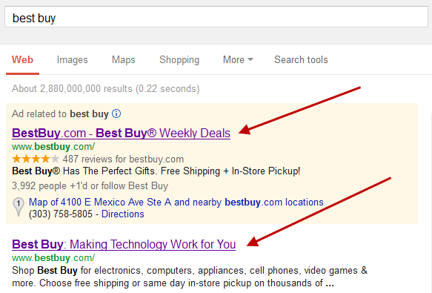

Transactional Search Queries

A transactional search query is a query that indicates an intent to complete a transaction, such as making a purchase. Transactional search queries may include exact brand and product names (like “samsung galaxy s3”) or be generic (like “iced coffee maker”) or actually include terms like “buy,” “purchase,” or “order.” In all of these examples, you can infer that the searcher is considering making a purchase in the near future, if they’re not already pulling out their credit card. In other words, they’re at the business end of the conversion funnel. Many local searches (such as “Denver wine shop”) are transactional as well.

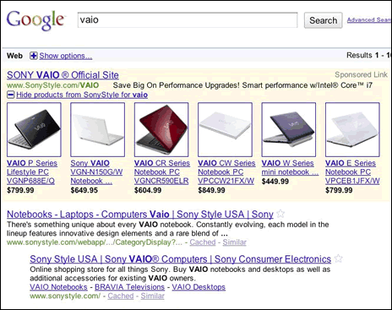

2]explain business factor that affacts SEO plan

A. There are many reasons why business can affect SEO and they are:

1.Target Market

Who do you want to sell to? Is the market specific like teenage boys or more broad like women 25+? Knowing the target market ahead of time, will allow for the individual pages to be optimised for the strongest keywords.

2.Revenue

What is the purpose of the site? Is it to produce content for visitors to read? Are you selling something?

3.Competitor Strategies

Who are your biggest competitors and how do you intend to best them? Are you trying to capitalise on a niche corner of the market or are you already an established brand hoping to destroy all opposition?

4.Budget

We have already covered that a perfectly implemented SEO strategy stands to deliver incredible ROI. As a result, early implementation is invaluable for a fledgling business.

5.The Minds of Your Customers

What do the members of your market think when expressing interest in your market? Knowing the most popular search queries of your customers and implementing them into the website is SEO 101.

6.Goals for Branding

Are there key phrases or terms you need to own?

3]what is SWOT analysis?how it is helpful in seo.

A. SWOT stands for:

* Strengths
* Weaknesses
* Opportunities
* Threats

A SWOT Analysis is typically applied to a company (and their competitive landscape) and is used to help determine high level strategy to achieve a company’s over-arching objectives. These objectives might be profit-led or growth-led; for example:

* Is it more important to build profits (profit-led) or sales (growth-led)?
* Do you want to sell more to existing customers (profit-led) or acquire new ones (growth-led)?
* Do you want to develop/improve existing products (profit-led) or add new products (growth-led)?

Of course in the real world it’s often not an ‘either/or’ scenario, but hopefully you get the picture.

4]short note:link analysis

a.

5] explain image optimization in SEO

A.image optimization is about reducing the file size of your images as much as possible without sacrificing quality so that your page load times remain low. It's also about image SEO. That is, getting your product images and decorative images to rank on Google and other image search engines.

1. }Name your images descriptively and in plain language

It's really easy to blow through hundreds of product shots and keep the default file names your camera assigns.

When it comes to image SEO, it's important to use relevant keywords to help your webpage rank on search engines. Creating descriptive, keyword-rich file names is crucial for image optimization. Search engines not only crawl the text on your webpage, they also crawl your image file names.

Take this image, for example.

2. }Optimize your alt attributes carefully

Alt attributes are the text alternative to images when a browser can't properly render them. They’re also used for web accessibility. Even when the image is rendered, if you hover over it, you will see the alt attribute text (depending on your browser settings).

3.}Choose your image dimensions and product angles wisely

It’s common practice to show multiple angles of your product. Going back to the Ford Mustang example, you wouldn't want to show just one shot of the car, especially if you're trying to sell it. It would be in your best interest to show shots of:

The interior.

The rear, especially that air spoiler.

The rims.

The engine... it is a Mustang after all.

4.} Reduce the file size of your images

6]explain flat v/s deep site architecture

a. 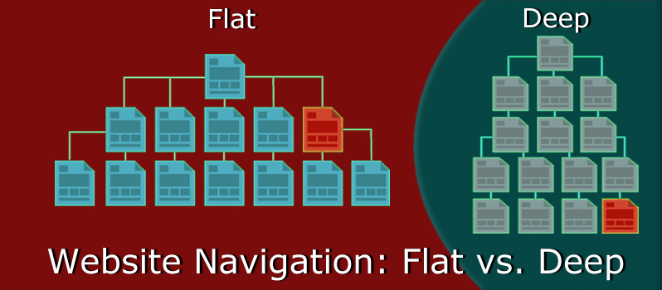

flat structures possess a horizontal hierarchy while deep architectures possess a vertical hierarchy. ... With flat architecture one can easily access most pages in only a few clicks from the home page. In comparison deep architecture requires more clicks due to the presence of multiple sublevels.

**Q-2[C]FIVE MARKS:**

1]explain various components of search engine result pages.

a. Search Engine Results Pages (SERP) are the pages displayed by search engines in response to a query by a user. The main component of the SERP is the listing of results that are returned by the search engine in response to a keyword query.

The results are of two general types, organic search (i.e., retrieved by the search engine's algorithm) and sponsored search (i.e., advertisements). The results are normally ranked by relevance to the query. Each result displayed on the SERP

normally includes a title, a link that points to the actual page on the Web, and a short description showing where the keywords have matched content within the page for organic results. For sponsored results, the advertiser chooses what to display.

[1Components](https://en.wikipedia.org/wiki/Search_engine_results_page#Components)

* [1.1Search query](https://en.wikipedia.org/wiki/Search_engine_results_page#Search_query)
* [1.2Organic results](https://en.wikipedia.org/wiki/Search_engine_results_page#Organic_results)
* [1.3Sponsored results](https://en.wikipedia.org/wiki/Search_engine_results_page#Sponsored_results)
* [1.4Rich Snippets](https://en.wikipedia.org/wiki/Search_engine_results_page#Rich_Snippets)
* [1.5**Featured Snippets**](https://en.wikipedia.org/wiki/Search_engine_results_page#Featured_Snippets)
* [1.6Knowledge Graph](https://en.wikipedia.org/wiki/Search_engine_results_page#Knowledge_Graph)

**Components**

The organic search results, query, and advertisements are the three main components of the SERP, However, the SERP of major search engines, like Google, Yahoo!, and Bing, may include many different types of enhanced results (organic search, and sponsored) such as rich snippets, images, maps, definitions, answer boxes, videos or suggested search refinements. A recent study revealed that 97% of queries in Google returned at least one rich feature.[2]

The major search engines visually differentiate specific content types such as images, news, and blogs. Many content types have specialized SERP templates and visual enhancements on the first search results page.

🡪Search query

Also known as 'user search string', this is the word or set of words that are typed by the user in the search bar of the search engine. The search box is located on all major search engines like Google, Yahoo, and Bing. Users indicate the topic desired based on the keywords they enter into the search box in the search engine.

In the competition between search engines to draw the attention of more users and advertisers, consumer satisfaction has been a driving force in the evolution of the search algorithm applied to better filter the results by relevancy.

Search queries are no longer successful based upon merely finding words that match purely by spelling. Intent and expectations have to be derived to determine whether the appropriate result is a match based upon the broader meanings drawn from context.

🡪Organic results

Organic SERP listings are the natural listings generated by search engines based on a series of metrics that determine their relevance to the searched term. Webpages that score well on a search engine's algorithmic test show in this list. These algorithms are generally based upon factors such as quality and relevance of the content, expertise, authoritativeness, and trustworthiness of the website and author on a given topic, good user experience and backlinks.[3]

People tend to view the first results on the first page.[4] Each page of search engine results usually contains 10 organic listings (however some results pages may have fewer organic listings). According to a 2019 study,[5] the CTR's for the first page goes as follows:

Position 1: 31.7%

Position 2: 24.7%

Position 3: 18.7%

Position 4: 13.6%

Position 5: 9.5%

Position 6: 6.2%

Position 7: 4.2%

Position 8: 3.1%

Position 9: 3%

Position 10: 3.1%

### Sponsored results[[edit](https://en.wikipedia.org/w/index.php?title=Search_engine_results_page&action=edit&section=4)]

*Main article:*[*Search engine marketing § Paid inclusion*](https://en.wikipedia.org/wiki/Search_engine_marketing#Paid_inclusion)

Every major search engine with significant market share accepts paid listings. This unique form of search engine advertising guarantees that your site will appear in the top results for the keywords you target. Paid search listings are also called sponsored listings and/or [Pay Per Click (PPC)](https://en.wikipedia.org/wiki/Pay_Per_Click) listings.

### Rich Snippets[[edit](https://en.wikipedia.org/w/index.php?title=Search_engine_results_page&action=edit&section=5)]

### Rich snippets are displayed by [Google](https://en.wikipedia.org/wiki/Google) in the search results pages when a website contains content in structured data markup. Structured data markup helps the [Google algorithm](https://en.wikipedia.org/wiki/Google_Algorithm_updates_in_2017) to index and understand the content better. Google supports rich snippets for the following data types:[[6]](https://en.wikipedia.org/wiki/Search_engine_results_page#cite_note-6)

* Product – Information about a product, including price, availability, and review ratings.
* Recipe – Recipes that can be displayed in web searches and Recipe View.
* Review – A review of an item such as a restaurant, movie, or store.
* Event – An organized event, such as musical concerts or art festivals, that people may attend at a particular time and place.
* Software Application – Information about a software app, including its URL, review ratings, and price.
* Video – An online video, including a description and thumbnail and It shows the three resources of answers image, content and URL in one box.
* News article – A news article, including the headline, images, and publisher info.
* Science datasets
* Job-related content

### Featured Snippets[[edit](https://en.wikipedia.org/w/index.php?title=Search_engine_results_page&action=edit&section=6)]

Featured Snippet is a summary of an answer to user's query. This snippet appears at the top of organic results on **SERP**. Google supports the following types of featured snippets:[[7]](https://en.wikipedia.org/wiki/Search_engine_results_page#cite_note-7)

* Paragraph snippet – Paragraph clearly comes from a longer list it gives brief answers through relevant keywords.
* Numbered / Bulleted – List of items that a user is searching to find those list or bulleted items are represented by Google through user's query.
* Table snippet – Answers are displayed based on required comparison. Google extract the data from content and reformat it into table snippet.
* Video – Google can show an exact video snippet from YouTube that corresponds to the search query and users can play it in the SERP.
* Combination of the aforementioned

### Knowledge Graph[[edit](https://en.wikipedia.org/w/index.php?title=Search_engine_results_page&action=edit&section=7)]

Search engines like Google or Bing have started to expand their data into [Encyclopedia](https://en.wikipedia.org/wiki/Encyclopedia) and other rich sources of information.

Google for example calls this sort of information "[Knowledge Graph](https://en.wikipedia.org/wiki/Knowledge_Graph)", if a search query matches it will display an additional sub-window on right hand side with information from its sources.[[8]](https://en.wikipedia.org/wiki/Search_engine_results_page#cite_note-8)[[9]](https://en.wikipedia.org/wiki/Search_engine_results_page#cite_note-9)

Information about the product (example Nike), hotels, events, flights, places, businesses, people, books and movies, countries, sports groups, architecture and more can be obtained that way.

2]explain advance google search operator in detail.

a. Advanced search operators are special commands that modify searches and may require additional parameters (such as a domain name). Advanced operators are typically used to narrow searches and drill deeper into results.

II. Advanced Search Operators

intitle: intitle:"tesla vs edison"

Search only in the page's title for a word or phrase. Use exact-match (quotes) for phrases.

allintitle: allintitle: tesla vs edison

Search the page title for every individual term following "allintitle:". Same as multiple intitle:'s.

inurl: tesla announcements inurl:2016

Look for a word or phrase (in quotes) in the document URL. Can combine with other terms.

allinurl: allinurl: amazon field-keywords nikon

Search the URL for every individual term following "allinurl:". Same as multiple inurl:'s.

intext: intext:"orbi vs eero vs google wifi"

Search for a word or phrase (in quotes), but only in the body/document text.

allintext: allintext: orbi eero google wifi

Search the body text for every individual term following "allintext:". Same as multiple intexts:'s.

filetype: "tesla announcements" filetype:pdf

Match only a specific file type. Some examples include PDF, DOC, XLS, PPT, and TXT.

related: related:nytimes.com

Return sites that are related to a target domain. Only works for larger domains.

AROUND(X) tesla AROUND(3) edison

Returns results where the two terms/phrases are within (X) words of each other.

3]major elements of SEO planning.

a.Technology Choices

As we already suggested, SEO is a technical process, and as such, it impacts major technology choices. For example, a CMS can facilitate—or, possibly, undermine—your SEO strategy. Some platforms do not allow you to have titles and meta descriptions that vary from one web page to the next, create hundreds (or thousands) of pages of duplicate content, or make a 302 (temporary) redirect the default redirect. All of these things could be disastrous for your website.

This problem also exists with web servers. For example, if you use Internet Information Services (IIS), the default redirect choice is a 302 (as we will explain in [Chapter 6](https://www.oreilly.com/library/view/the-art-of/9781449324865/ch06.html), a 301 [permanent] redirect is essential for most redirect applications). You can configure IIS to use a 301 redirect, but this is something you need to understand how to do and build into your SEO plan up front.

Market Segmentation

Another critical factor to understand is the nature of the market in which you are competing. This tells you how competitive the environment is in general, and augmented with additional research, you can use this information to tell how competitive the SEO environment is.

In some markets, natural search is intensively competitive. For instance, [Figure 4-1](https://www.oreilly.com/library/view/the-art-of/9781449324865/ch04s01.html#sample_results_for_a_competitive_query) shows the December 2012 Google results for *credit cards*. In this market, Visa, MasterCard, American Express, and Discover all fail to make the #1 position in Google’s results, suggesting that the market is highly competitive.

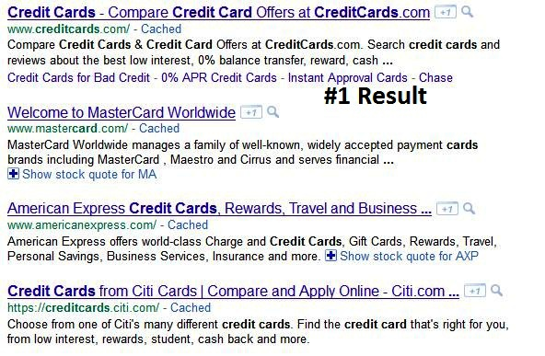

*Figure 4-1. Sample results for a competitive query*

This does not mean you should give up on the market, especially if it is already the focus of your business; however, you might choose to focus your SEO efforts on less competitive terms that will still bring you many qualified leads.

Another method you can use to get a very quick read on competitiveness is using a keyword tool such as the Google Traffic Estimator (<https://adwords.google.com/select/TrafficEstimatorSandbox>) to see what your cost per click would be if you bid on your target phrase in a PPC campaign.

Where You Can Find Great Links

As you will see in [Chapter 7](https://www.oreilly.com/library/view/the-art-of/9781449324865/ch07.html), getting third parties to link their websites to yours is a critical part of SEO. Without inbound links, there is little to no chance of ranking for competitive terms in search engines such as Google, whose algorithm relies heavily on link measuring and weighting criteria.

An early part of the SEO brainstorming process is identifying the great places to get links, as well as the types of content you might want to develop to encourage linking from other quality websites. Note that we, the authors, advocate pursuing few, relevant, higher-quality links over hundreds of low-quality links, as 10 good links can go much further than thousands of links from random blog posts or forums. Understanding this will help you build your overall content plan. The authors also have noticed a strong increase in text link spam being utilized by SEO practitioners, in the form of mass-produced article, forum, and blog postings with keyword text links in the name and/or signature. At the time of this second edition’s publishing, Google specifically was still rewarding this behavior for many queries, allowing websites whose backlink profiles are overwhelmingly link-spammy to rank on the first page of results. The authors strongly believe that this dubious practice is ill-fated and will be targeted and flushed out by Google in the future. We do not recommend using this strategy.

Content Resources

The driver of any heavy-duty link campaign is the quality and volume of your content. If your content is of average quality and covers the same information dozens of other sites have covered, it will not attract many links. If, however, you are putting out quality content, or you have a novel tool that many will want to use, you are more likely to receive external links.

At the beginning of any SEO campaign, you should look at the content on the site and the available resources for developing new content. You can then match this up with your target keywords and your link-building plans to provide the best results.

Branding Considerations

Of course, most companies have branding concerns as well. The list of situations where the brand can limit the strategy is quite long, and the opposite can happen too, where the nature of the brand makes a particular SEO strategy pretty compelling. Ultimately, your goal is to dovetail SEO efforts with branding as seamlessly as possible.

Competition

Your SEO strategy can also be influenced by your competitors’ strategies, so understanding what they are doing is a critical part of the process for both SEO and business intelligence objectives. There are several scenarios you might encounter:

* The competitor discovers a unique, highly converting set of keywords.
* The competitor discovers a targeted, high-value link.
* The competitor saturates a market segment, justifying your focus elsewhere.
* Weaknesses appear in the competitor’s strategy, which provide opportunities for exploitation.

Understanding the strengths and weaknesses of your competition from an SEO perspective is a significant part of devising your own SEO strategy.

4]keyword research tool.explain any three

A. 5.10

5]how to make your site accessible to search engine?

a. Optimize your web page using Search Engine Optimization (SEO). Enumerated here are some list of SEO Techniques:  
  
1. Meta Tags  
Meta Tags are designed to provide search engines what your site is all about. These are information inserted in the [head] area of the HTML code of your web pages. They are commonly not visible to the person surfing your web page but is intended for the search engine crawlers. Meta tags are included so that search engines are able to list your site in their indexes more accurately. Here is an example of what a Meta Tag would look like if you click on the view "Page Source" from your browser menu.  
  
[HEAD]  
[TITLE]Creating Successful meta tags, list of all meta tags, title tag limit, href tag, meta tag analysis[/TITLE]  
[meta name="description" content="Successful Meta tags: What are meta tags? Meta tag analysis, list of all meta tags, title tag limit, creating meta tags, background meta tags. This article covers the most important aspects of meta tags in relation to website optimization or SEO. "]  
[meta name="keywords" content="meta tags, meta tag refresh, meta tag optimization, meta tag analysis, meta tag keywords, what are meta tags, successful meta tags, using meta tags, html meta tags, common meta tags, author meta tag, alt tags, list of all meta tags, meta tags html, meta tag description, about meta tags"]  
[/HEAD]  
  
2. Title Tags  
Title Tag is an HTML code that shows the words that appear at the top title bar of your browser. These words or phrases appear as the title of your page in the listings on the search engine results. The title is the first thing people will see when search engine results are displayed. It is also important that you indicate your Domain Name in the Title and Meta Tags of your page for search engines to recognize your site. Include your most relevant and specific keywords or key phrases in the Title Tag describing the content of your page. Syntax for the Title Tag is:  
  
[HEAD]  
[TITLE]Creating Successful meta tags, list of all meta tags, title tag limit, href tag, meta tag analysis[/TITLE]  
[/HEAD]  
  
3. Links  
The process of submitting your site to search engines can take from a few weeks to several months. However, even a new site will be indexed rapidly, if it has incoming links. Google explains that, "The best way to ensure Google finds your site, is for your pages to be linked from lots of pages on other sites. Google's robots jump from page to page on the Web via hyperlinks, so the more sites that link to you, the more likely it is that we'll find you quickly."  
  
4. Keyword Phrases  
Use specific keywords that would best describe your website. It is always effective to use similar text in the title and description tags and to place your keywords prominently in these tags. You can browse Google Adwords Keyword Suggestions (https://adwords.google.com/select/KeywordToolExternal) for suggestions for different keyword phrases.  
  
5. Keyword Density  
The number of times a keyword or phrase is used on a web page divided by the total number of words on the page. This is important because search engines use this information to categorize a site's theme. Keyword density needs to be balanced correctly (too low and you will not get the optimum benefit, too high and your page might get flagged for "keyword spamming").  
  
6. Site Map  
A good menu system is really a site map. Having an easy navigation throughout the website is the key. A well constructed menu system that is on each page and contains a link to every page on the website is all you need.  
  
7. Site Design  
If your website has a bad color scheme that is hard to read and not organized then all your site optimization is just a waste of time. Make your site attractive to viewers, having accessible links with your graphic header and menu bar in the same place on each page.  
  
8. Site Themes  
All of the top three search engines look for site themes or a common topic when they crawl a website. Having one specific topic will make you rank better than having more than one theme or topic on your site. By using similar keyword phrases in each page, the search engines will detect a theme and that will be your advantage to achieve high search engine positioning.  
  
9. Site Submission  
Search engines crawl the web weekly and take a look at your html codes. It is highly recommended to submit your website to Yahoo, Google, MSN, Altavista, etc., as well as other local search engine websites eg. Yehey.com. It usually takes about 30-90 days before you are ranked or your site to be visible on the search engine listings. Submit your site to Google at https://www.google.com/addurl/?continue=/addurl.

10. Naked Domain Redirection To WWW  
As a part of search engine optimization techniques, one important step is to make sure that naked domain redirects to www.domainname.com using htaccess file. It is because search engines treat naked domain(domainname.com) and www.domainname.com as two different sites and google does not like it when a naked domain shows the exact content of www. Google penalizes site with duplicate content.

**Q-3[A]TWO MARK:**

1]what is KEI?explain it.

a. . KEI (keyword effectiveness index) is one of the quickest ways to find keywords that show potential - that is, those keywords which are likely to help your site attract more traffic.

Keyword Effectiveness Index is an indicator used to shortlist keywords that are not only easier to rank well but also drive higher traffic.

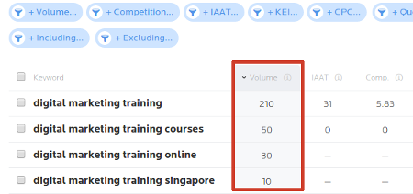

* Enter a keyword and search. Example: digital marketing training.
* It has a monthly search volume of 210. Note down this number. Search volume is the number of times the keyword has been searched on a search engine in a month.
* Now open Google search engine and search for “digital marketing training” (along with the double quotes). Google returned 10,60,000 results. Note this number. This is the number of competing pages. By using double quotes, we are telling Google to search for the exact words in the exact order.  
  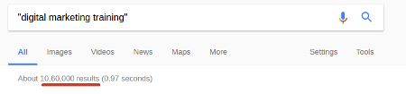
* Calculate the KEI using the below formula:  
  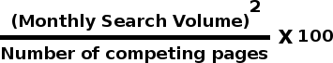
* Let us calculate KEI for 'digital marketing training'  
  https://datasasi.com/blogpics/KEI-Example.png
* KEI for 'digital marketing training' is 4.16. Calculate the KEI for all the keywords related to your industry and shortlist the keywords with higher KEI. This list will form the basis for your SEO plan.

2]SHORT NOTE:analyzing ranking factor

* a. Keyword use in title tag
* Anchor text of inbound link
* Global link authority of site
* Age of site
* Link popularity within the site’s internal link structure
* Topical relevance of inbound links
* Link popularity of site in topical community
* Keyword use in body text
* Global link popularity of sites that link to the site

3]how to optimize domain name/URL

1. a. Make your **domain name** memorable. ...
2. Use broad keywords when sensible. ...
3. Avoid hyphens if possible. ...
4. Avoid non-.com top-level **domains** (TLDs) ...
5. Favor subfolders/subdirectories over subdomains. ...
6. Don't sweat over **domain** age.
7. Moving domains

4]what is e-coommerce sales?

a. **Ecommerce SEO** is the process of making your online store more visible in the search engine results pages (SERPs). When people search for products that you sell, you want to rank as highly as possible so you get more traffic. You can get traffic from paid search, but **SEO** costs much less.

Ecommerce SEO usually involves optimizing your headlines, product descriptions, meta data, internal link structure, and navigational structure for search and user experience. Each product you sell should have a dedicated page designed to draw traffic from search engines.

5]explain how to do optimize for domain names?

a.6.20

6]what is clocking?explain use and how?

a. Cloaking is a method which gives [search engines](https://www.searchmetrics.com/glossary/search-engine/) the impression that a [website](https://www.searchmetrics.com/glossary/websites/)carries content that is different to what users actually see.

**Clocking** in **SEO** is nothing but showing different content to the users and totally different content to Googlebot (search engine spider). For example, you optimize a page with some text or keywords for search engines while your showing prohibited/un-related images to the users.

It helps to show the different content to crawler and user with the help of Id Address. clocking is black hat seo this is a type of link that doesnt have any content inside. A webpage appears different for search engines and humans, t

Let us now understand how to put cloaking into action with a few easy pointers:

* **Invisible or Hidden text**

This can be done by adding text in the same colour as that of the background so that it is not visible to the human eye.

* **Flash-based Websites**

We know Flash is not recommended as per SEO guidelines. But some websites cannot avoid it. So rather than remaking the entire website in plain HTML, they create content-rich webpages and provide them to search engine crawlers and the flash pages to visitors.

* **HTML Rich Websites**

A good [SEO technique](https://www.infidigit.com/blog/on-page-seo/) requires having a “TEXT to HTML ratio” that is as high as possible. In other words, the web page should have more text (content) as compared to your HTML tags. But if someone is writing short articles or posts, your text to HTML ratio will be very low. To avoid re-designing their website in such scenarios, people choose cloaking to meet SEO guidelines.

* **Replacement of Java Scripts**

Here, one can use JavaScript to show content to a non-JavaScript enabled user that matches the textual information within a Flash or other multimedia element.

**Q-3[B]THREE MARK:**

1]short note:robot.txt.file

a. A robots.txt file tells search engine crawlers which pages or files the crawler can or can't request from your site. This is used mainly to avoid overloading your site .

robots.txt is used primarily to manage crawler traffic to your site, and usually to keep a page off Google, depending on the file type:

In short, a Robots.txt file controls how search engines access your website.

This text file contains “directives” which dictate to search engines which pages are to “Allow” and “Disallow” search engine access.

**Basic format:**

User-agent: [user-agent name]Disallow: [URL string not to be crawled]

* In order to be found, a robots.txt file must be placed in a website’s top-level directory.
* Robots.txt is case sensitive: the file **must** be named “robots.txt” (not Robots.txt, robots.TXT, or otherwise).
* Some user agents (robots) may choose to ignore your robots.txt file. This is especially common with more nefarious crawlers like malware robots or email address scrapers.
* The /robots.txt file is a publicly available: just add /robots.txt to the end of any root domain to see that website’s directives (if that site has a robots.txt file!). This means that anyone can see what pages you do or don’t want to be crawled, so don’t use them to hide private user information.
* Each subdomain on a root domain uses separate robots.txt files. This means that both blog.example.com and example.com should have their own robots.txt files (at blog.example.com/robots.txt and example.com/robots.txt).
* It’s generally a best practice to indicate the location of any [sitemaps](https://www.sitemaps.org/index.html) associated with this domain at the bottom of the robots.txt file. Here’s an example:

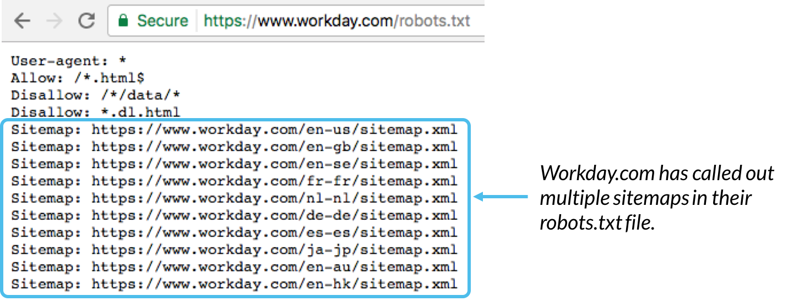

2] what is A/B test?what is use.

a. A/B testing (also known as split testing or bucket testing) is a method of comparing two versions of a webpage or app against each other to determine which one performs better.

A/B testing lets you know what words, phrases, images, videos, testimonials, and other elements work best. Even the simplest changes can impact conversion rates.

3] explain paid v/s natural results

a. Natural

• The advantage of organic search marketing is that organic listings are more trusted by searchers than paid listings.

• Most searchers are Confident enough to realize that Google has a say in what shows up in their searches, and that paid listings are more about who has the deeper pocket.

• Top organic positions also attract 50% more attention than top paid positions (Source).

• The disadvantage of organic search is that it can be tricky to get top rankings if you don’t know what you are doing.

• Search engine optimization services base their entire businesses around raising their clients’ rankings.

• SEO services are highly valued by companies because a top position in Google for a competitive keyword can skyrocket leads and sales.

• These companies improve their clients’ rankings via proper search engine optimization.

• Search engine optimization is the act of optimizing a website to be more search engine friendly and increasing its perceived importance in the eyes of a search engine.

• Google uses complex ranking algorithms to determine which websites will be listed nearest the top of the page.

• If your website isn’t properly optimized, you could be losing out.

Paid

• The obvious disadvantage of paid search marketing is that you have to pay for it. Paid search marketing is also commonly referred to as pay per click (PPC) marketing.

• The rate you are charged per click varies upon your market and your preferred ranking.

• A company paying $0.30 (17rs) /click will likely not rank above a company paying $0.40 (23rs) /click (there are some exceptions but for simplicity sake, this holds true).

• The advantage of paying per click is that you have complete control over which terms your website will be listed under– in real time.

• This is especially useful when you aren’t sure about which keywords yield the highest returns.

• Using PPC management tools, you can easily determine which keywords are working best for your website.

• The right choice for your website depends on your particular needs and desires. • Most websites benefit most from utilizing a combination of these two approaches.

• Using PPC marketing can help you quickly identify your best performing keywords, while implementing a longer-term SEO strategy will increase your chances of ranking well in the organic listings.

4]describe server statistics software

a.

5]how you audit website to identifiy seo problems?

a. Here are some factors to consider as you audit your website to identify [search engine optimisation](https://www.mikencube.co.uk/services/search-engine-optimisation/) (SEO) problems:

**USABILITY**

Usability is an important factor to improving sales, conversions and other actions on your website. It doesn’t have a direct effect on [SEO](https://www.mikencube.co.uk/10-seo-marketing-plan-tips-higher-google-rankings/) but in the long term interactions with your site will determine the bounce rate and ultimately the positions that you acquire and keep in the Natural Search Engine Results Pages (SERPs).

**ACCESSIBILITY/SPIDERABILITY**

The site should be friendly to visitors and search engines and should be easily indexed by the search bots. The site architecture should be optimal for visitors to find what they need within a few clicks and search engines shouldn’t struggle to find inner pages that are important for your business.

**SEARCH ENGINE HEALTH CHECK**

Check the search engines to see how many pages on your site have been indexed by using the syntax *site:yourdomain.com* and compare this with the number of unique pages you believe your site has. Also search for your brand names to see how you rank for them, then take corrective action if you rank low for your names. And check the cached versions of your pages match the live versions of your pages.

**KEYWORD HEALTH CHECK**

Are you targeting the right keywords in your content and link building strategy? Have you included keywords in the correct density, about 2-5%, on all pages? Does more than one page target the same keyword, also known as keyword cannibalisation? Make sure you fix these and other keyword factors to ensure that your targeting is precise and will lead to good traffic volumes.

**DUPLICATE CONTENT CHECK**

Check that you don’t have https pages that are duplicates of http pages because this could lead to a search engine penalty. Also, ensure that each page has unique content that is not duplicated on other pages.

**URL CHECK**

URLs should be clean, short and descriptive and that means they should be keyword rich and not keyword stuffed. You also want them to be simple and easy to understand by both search engine spiders and human visitors.

**TITLE TAG REVIEW**

Title tags for homepage and all other pages should be unique and descriptive. Company or brand names should be included at the end of the tag and not at the beginning because that is where you will add keywords that you want to rank for.

**SITEMAP FILE VERIFICATION**

Use the Google Search Console platform to add and verify your sitemap to make sure that all your URLs are indexed and are appearing in search results.

**INTERNAL LINKING CHECKS**

Check for pages that have excessive links and ensure that they are not more than 100, per Google’s advice, however it’s ok to have more on very important pages that are heavily linked to.

6]discuss on leveraging the long tail of keyword demand.

a. **Long Tail Keywords** are the **longer**, highly specific phrases people use when searching in search engines. **Long tail keywords** are search phrases with **longer** word counts. ... “Buy breathable running socks” (4 words) is an **example** of a **long tail keyword**, whereas “buy socks” is a short **tail keyword**.

**Q-3[C]FIVE MARKS:**

1]WHAT IS CMS?list ot the issues to consider while using CMS.

a. Picking a CMS (content management system) platform for your website is a smart idea. And there are many good content management systems to choose from that offer you the ability to update and control content on your website without advanced technical knowledge.

* They don't allow for title tag customization. ...
* Long, URL's that aren't static. ...
* Not allowing meta tag customization. ...
* Not allowing flexibility of internal anchor texts. ...
* Not enabling custom HTML tags. ...
* Not allowing for 301 redirects. ...
* No RSS pinging. ...
* Poor image handling.

1. **They don’t allow for title tag customization.**  
   A search engine friendly CMS allows for all title tags to be customized (page specifically).
2. **Long, URL’s that aren’t static.**  
   URLs pose problems for SEO when it comes to CMS platforms—ideally your platform should assist with URL creation and allow for custom keyword rich URLs, hyphenated for separation.  Your CMS platform should auto generate titles based on posting titles (if you’re lazy) or enable manual changing of URLs.
3. **Not allowing meta tag customization.**  
   Both meta tags, meta descriptions, and robot tags are critical for a good SEO friendly CMS.
4. **Not allowing flexibility of internal anchor texts**Having the ability to customize anchor text on internal links is critical.  In order to optimize your website, your CMS platform should provide the flexibility to handle custom input.
5. **Not enabling custom HTML tags.**  
   A SEO friendly CMS system has the ability to offer extra functionality when it comes to “nofollow” links, HTML tags, or other subheadline or headline tags.
6. **Not allowing for 301 redirects.**  
   Allowing for 301 redirects are an absolute must for SEO.  Unfortunately, some CMS platforms lack this feature—these redirects are crucial for taking care of expired content, pages with newer versions, solving duplicate content issues, multiple domain issues, etc…
7. **No RSS pinging.**  
   A CMS that doesn’t allow for pinging limits exposure—CMS that allow pinging are useful for articles, press releases, pages, and blog posts.
8. **Poor image handling.**  
   Alt tags on images are a must for SEO—they serve as “anchor text” for the search engines.
9. **Poor categorization.**  
   Just like URL creation, categorization should be flexible.  Any CMS platforms offering customizable navigation will be a SEO success.

2]describe importance of new trends search

a.

3]discuss optimization process for news,blog and feed search

a. **news:**The news search engines are looking for content that is in the form of either a news story or a feature story. They also are looking to see that you are creating news content in reasonable volume—a minimum of 10 articles per week. News sites are looking for news sources (i.e., sites), not individual news pieces. In addition, as mentioned previously, be aware that both Yahoo! News and Google News very rarely accept new sources. Investing in building a news feed to try to get into these new search engines is an iffy proposition at best, and should only be pursued if you are already committed to producing very high quality news content.

Guidelines for the content are the same as they are for traditional news. The articles should have a catchy, keyword-rich headline and a strong opening paragraph.

The opening paragraph should draw the reader in so that he will read the rest of the article. In traditional news, the main compelling point is put forth at the start, and the discussion continues through other points of descending importance. The news piece should end with a strong concluding paragraph that reviews the major points of the article.

**Blog Optimization**

Blogs are great publishing platforms for those who want to write articles on a regular basis. First, they make it easy to publish the content. Authors only need to log in and use a relatively simple set of menu choices to input what they want to publish, preview it, and then proceed to publish it. It is far easier than coding your own HTML pages by hand.

In fact, it is so easy that entire websites have been built using WordPress as the sole publishing platform. These sites are also typically easy to set up and configure. The world’s most popular blog platform is [WordPress](http://www.wordpress.com/), but the blog platforms from [Moveable Type](http://www.moveabletype.org/) and [TypePad](http://www.typepad.com/) are also popular.

Blogs are inherently social in nature, and a host of social marketing benefits come from blogs. Enabling comments allows for interaction with your readers, and bloggers tend to have a significant level of interaction. For example, one blogger may write a post that reacts to or comments on another blogger’s post. A lot of cross-linking takes place, with one blogger citing another.

Working this aspect of blogging as a social media platform is beyond the scope of this book. Nonetheless, be aware that a blog is an opportunity to establish yourself as an expert in a topic area, and to engage in a give-and-take activity that can dramatically change the visibility of your business.

In addition to these huge benefits, blogs can also bring you search engine and/or blog search engine traffic when they are properly optimized.

## Feed Optimization

Many people mistakenly lump blogs and RSS together, but RSS has infinitely more applications beyond just blogs. RSS feeds can also be used for reporting upon or announcing news alerts, your latest specials, clearance items, upcoming events, new stock arrivals, new articles, new tools and resources, search results, a book’s revision history, top 10 best sellers (as Amazon.com does in many of its product categories), project management activities, forum/listserv posts, and recently added downloads. A good place to start is with basic SEO practices, as we’ve outlined elsewhere in the book (providing good titles and descriptions, handling tracking URLs properly, etc.).

Here are the basics for RSS feed optimization:

* If practical, use the full text of your articles in your feeds, not summaries. A lot of users want to read the full article in the feed without having to click through to your site. This is a case where you need to focus more on the relationship with the user than on immediate financial goals.
* Consider multiple feeds. You can organize them by category, latest comments, comments by post, and so on.
* An RSS feed that contains enclosures (i.e., podcasts) can get into additional RSS directories and engines, as there are many specialized directories just for podcasts or other types of media.
* Make it easy to subscribe. Ideally, users should have to click only once to subscribe via their favorite aggregator. You can do this through “Add to ____” (My Yahoo!, Bloglines, Google Reader, etc.) buttons on your site. Also make sure to implement <link> tags for auto-discovery (e.g., <link rel="alternate" type="application/rss+xml" title="RSS" href="http://feeds.stephanspencer.com/scatterings" />) in the <head> section of your web pages.

4]short note:Tying SEO to conversion and ROI.

# a. Tying SEO to Conversion and ROI

As we discussed previously in this chapter, it is important to tie your SEO campaign to the results it brings to the business. Key to that is measuring the conversions driven by organic SEO traffic. Here are some of the most common types of conversions:

Sales/sales revenue

This is the one most people think of when they think of conversions. Sales and sales revenue (or better still, margin) conversions can be the simplest things to track, provided you are not selling many different products at different price points and in different quantities. In that case, the process needs to be a bit more sophisticated.

If your site is advertising-driven, you need to look at the impact of organic search traffic on advertising revenue. If you have no financial goals for your site, you need to look at some of the other types of conversions and determine their value or worth.

Email/blog/newsletter subscriptions

Any time a user signs up to receive regular communications from you, it is a win. Even though this action does not have direct financial consequences, it is still a conversion. Someone who has subscribed to something you offer is more likely to become a customer than a first-time visitor to your site, so you need to credit this type of conversion.

Sign-ups

Closely related to subscriptions are other types of sign-ups. Perhaps you offer a service such as a tool that people need to sign up to use. Even if the tool is free, you should track this as a conversion.

You most likely received the person’s email address in the process, and even if she indicates that she does not want to receive commercial communications from you, you should be building loyalty with the tool you provided her access to (or whatever it is that she signed up for); otherwise, why would you be providing her with that product or service?

Downloads

Many sites offer free downloads, such as white papers, or free downloadable tools. Even if you do not require a sign-up of any type, you should still count a download as a conversion. You are getting your message out there with the downloads you offer.

5]give importance of local,mobile and voice recognition search

a.9.8